Tel/fax: 01223 302535
email: maelliott@tcme.fsnet.co.uk
THE SHERWOOD RANGERS YEOMANRY REGIMENTAL ASSOCIATION

From: Capt MA Elliott
Hon Secretary
7th March 2017

Dear Member,

AGM and ANNUAL DINNER - Saturday 22nd April 2017

This year's Annual Reunion Dinner will be held at 6.30 for 7.00pm on Saturday 22nd April at the TA Centre, Carlton, by kind permission of the Squadron Leader, Major Angus Jenkins.

The cost of the Dinner will be £25 per person to include wine and port. The South Notts Hussars Band will play during the meal. Full details are enclosed on a separate sheet. I hope that as many members as possible will attend. Please apply to me (or to the SSM if you are a serving member) in good time. If you apply to me please use the correct form (attached). We will always try to accommodate latecomers but if a large number of people turn up at the last minute it makes life very difficult for the organisers.

Guests are welcome at the dinner but must be connected with the SRY or other regiments.

Serving members of A Sqn should, as usual, obtain their dinner tickets from the Squadron. However, if you put your name on the Squadron list, please do not order a ticket from me as well or you will have to pay twice.

Raffle. At the Dinner, we shall again be holding a raffle and any donations of prizes will be gratefully received. Last year’s raffle collected £180 and I am most grateful to all who contributed.

This year, I am sending some of these newsletters by email, especially to members living abroad where the cost of postage is becoming prohibitive, but also to some in the UK for whom we only have email details. I apologise if, due to our incomplete records, some people get it twice. At least the electronic version has the photos in colour which is unfortunately too expensive for the printed copies.

Annual General Meeting

The AGM will be held immediately before the dinner at 6.00pm. The Agenda and a copy of the Minutes of the last meeting are enclosed. The Accounts will be presented at the meeting.

OBITUARIES

I am sorry to have to report the deaths since my last circular of a number of members as follows:

Mr A Chandler | - | Chalfont St. Peter |  | Mr S Pezaro | - | Nottingham
Mr E Hare | - | Clitheroe |  | Capt JKE Stanford OBE 17/21L | - | Salisbury
Mr J Lancaster | - | Eastwood |  | Maj JD Semken CB MC | - | Aldeburgh
Mr CE Mackintosh | - | Tain

Maj John Semken was the last surviving of the officers that joined the SRY from the Inns of Court Yeomanry at the beginning of the WW2. He served in Palestine, North Africa and North West Europe where he led A Sqn with great distinction. He was a strong supporter of the Association and led many of our battlefield tours. A full obituary is attached to this letter.
Capt James Stanford was Adjutant of the SRY when it was a regiment during the 1960s.
Members will also be sorry to hear of the death during the year of Maj Gen The Duke of Westminster. One of the most prominent and successful TA officers of his day, he commanded the Queen’s Own Yeomanry during the time that the SRY was part of that regiment.

MIDLANDS BRANCH

I attach a copy of the Midlands Branch annual report detailing its activities in the past year. The Chairman is John Maltby and the Secretary Tony Higton. The Branch has its own clubroom at Carlton where it meets on the fourth Wednesday of each month. Serving members are invited join the Branch members for a drink and buffet after the end of their parade so that both groups can have a chance to get to know each other. If you are interested in joining, please contact one of the committee members on the telephone numbers shown on the report.

ARNOLD BRANCH

The Arnold Branch continues to grow in strength and meets at Mapperley Golf Club on the second Tuesday of the month at 1900 hrs. Its membership consists of Sherwood Rangers and attached personnel who served in the Sqn from the seventies to the present time. Wives and partners are very welcome at these meetings although membership is restricted those that have served with the Sqn.

During the year, the Branch held 12 monthly meetings with an average attendance of 25 plus and four major functions including a black tie El Alamein dinner. It also organised and ran four trips including a coach to the Cavalry Memorial Parade (which it is doing again this year).

The Branch continues to grow financially and is healthy cash-wise but its main aim to bring together old comrades and friends to promote fellowship and caring for one another.

The Branch does not send out a printed newsletter but has built an email distribution list of over 70 members which anyone can be added to by contacting the Secretary Capt Alan Brooks via the contact listed on the website.

A (SRY) Squadron THE ROYAL YEOMANRY

The major event during the year was the presentation by the Royal Honorary Colonel, Princess Alexandra, of the new Royal Yeomanry Guidon. This carries a selection of the major battle honours of the former regiments and the Royal Yeomanry honour Iraq 2003. The latter is a unique distinction in that it is the only battle honour awarded to a TA regiment since the Second World War.

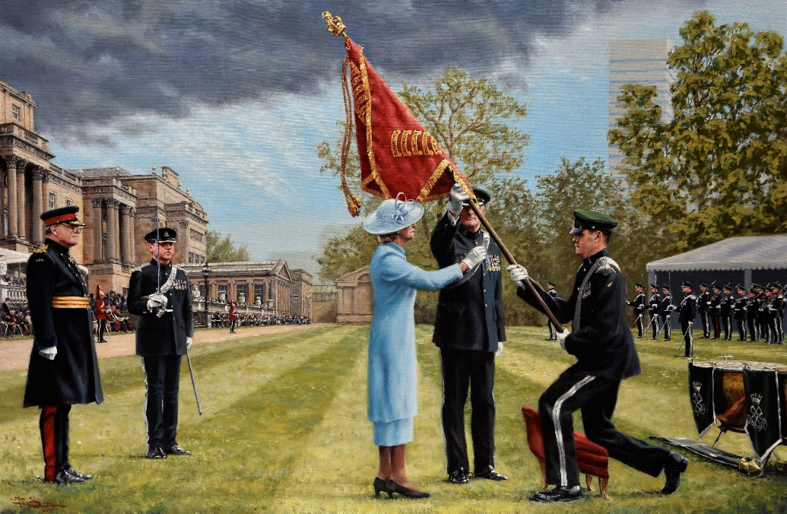
Painting by Capt Hugh Beattie http://www.jhlb.co.uk/

The parade was a great success and a great credit to all involved. Originally planned for Windsor Castle, the venue was switched at the last minute to the gardens of Buckingham Palace due to conflicts with the Queen’s 90th birthday celebrations at Windsor. This proved to be an inspired choice as there was much more space and, with all the facilities for the summer season of royal garden parties in place, the ability to put on a really grand occasion.

The preparations were hectic, not least all the rehearsals and the need to fit everyone with the correct uniforms. However, all concerned worked extremely hard and the result was a spectacular afternoon which will long be remembered by all that attended.

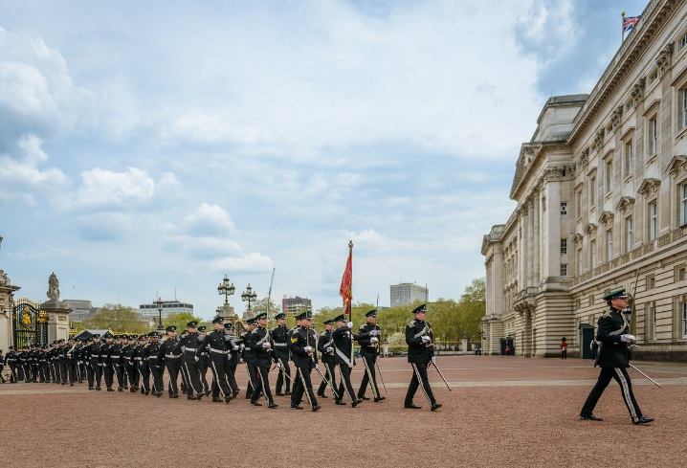
A (SRY) Squadron Leading the Regiment to Buckingham Palace
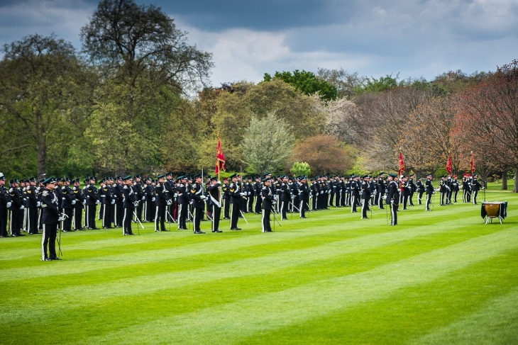
The Royal Yeomanry on Parade in the Palace Gardens

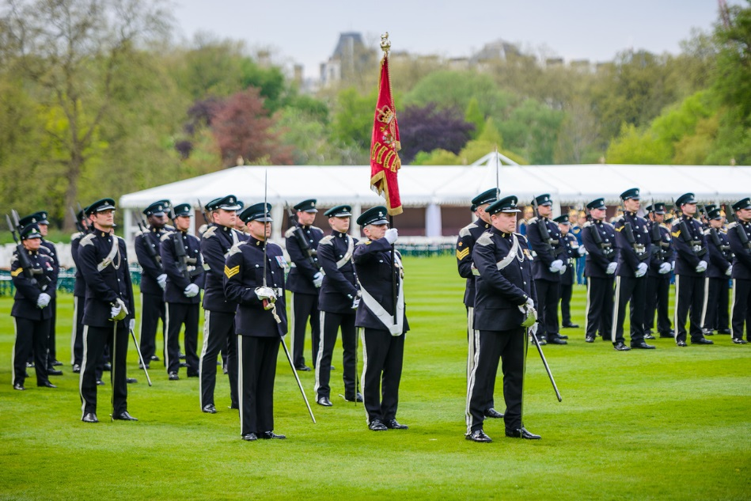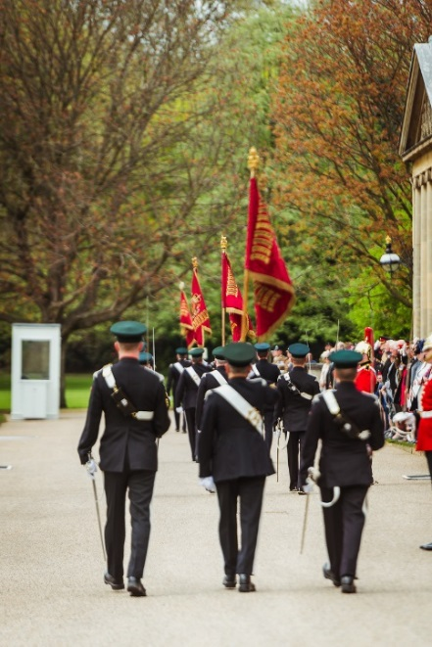
A(SRY) Squadron with the SRY Guidon The old Guidons are Marched Off

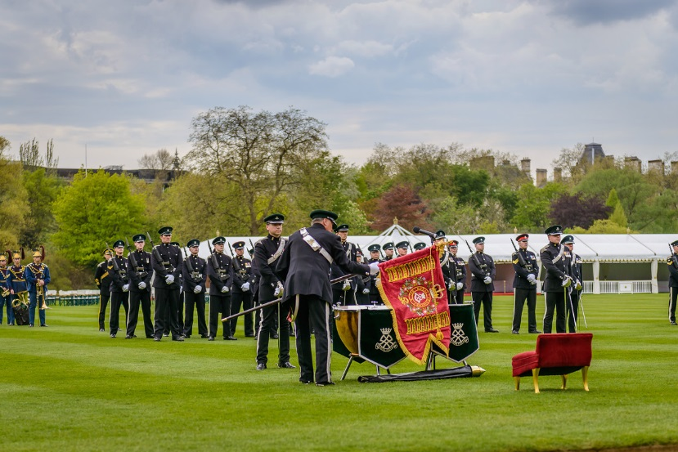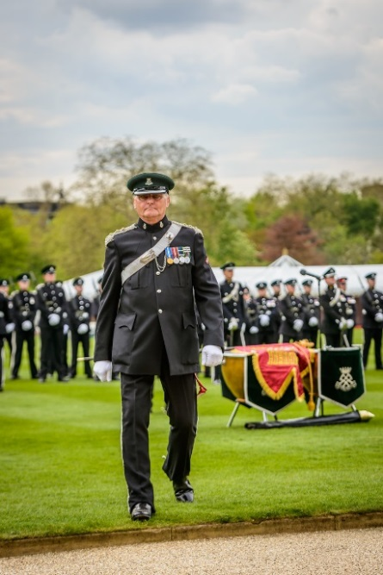
Capt Grenville Turner of A (SRY) Sqn unfurls the new Guidon and Marches Off
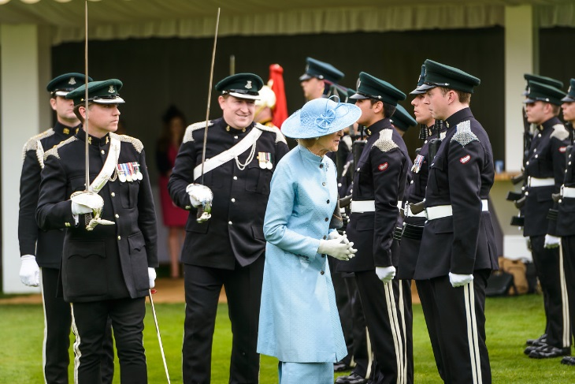
Princess Alexandra inspecting A (SRY) Squadron

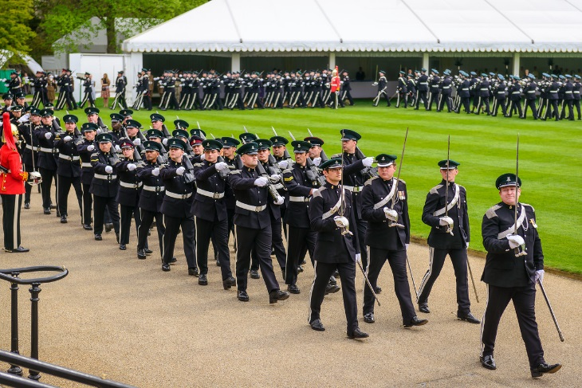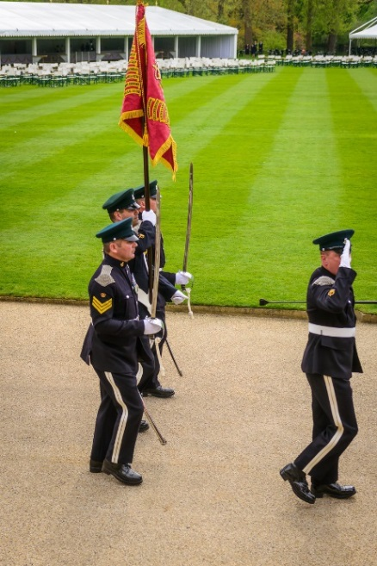
A (SRY) Squadron Marching Past The new Royal Yeomanry Guidon

Maj Jenkins’ tour as Squadron Leader will finish in April. He leaves the Squadron in excellent form and we are most grateful for his support for the Association over the years. We offer him our best wishes for the future and welcome his successor Capt Simon Hallsworth, currently 2ic.

NATIONAL MEMORIAL ARBORETUM

For some time we have had a tree in Yeomanry Avenue at the National Memorial Arboretum. Many regiments also have a memorial there and it has been proposed that we should have one as well.

Brig Michael Browne has kindly agreed to run an appeal to raise the necessary funds. I enclose a letter from him giving more details and would urge you support this. All donations, large and small would be most gladly received.

CAVALRY MEMORIAL PARADE - Sunday 14th May 2017

This year the Cavalry Memorial Parade will be held on Sunday 14th May in Hyde Park and I hope that the Regiment will be well represented. The Arnold Branch will be organising a coach from Nottingham with lunch at Bushey on the way home. If you would like more details of this, please contact the Branch Secretary Capt Alan Brooks via the contact us link .

The RY will also be organising the usual lunch after the parade. I do not have any more details at the moment but, if you would like to attend, please let me know as soon as possible, preferably by email to the address at the head of this letter, and I will give you the details when received.

Finally, here are some photos of last year’s parade:

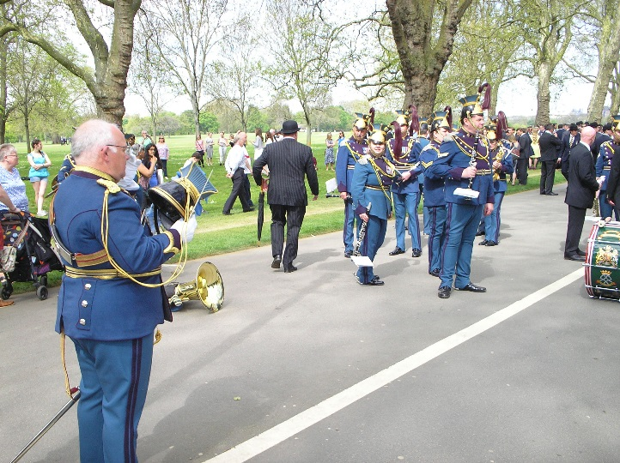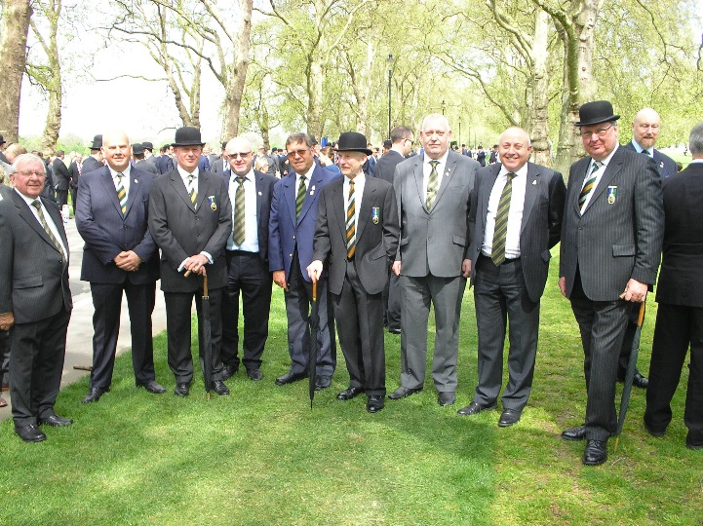
Before the parade last year

NORMANDY JUNE 2016

On 6th June we went to some of the sites that the Secretary and Capt Render had discovered during their trip with Col Stuart Tootal the previous October, in particular at Jurques and Berjou. We also followed the routes taken by the different squadrons at Berjou where we met our local contact Jean-François Brisset.

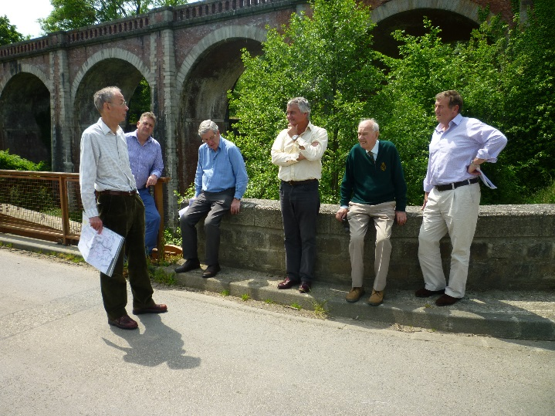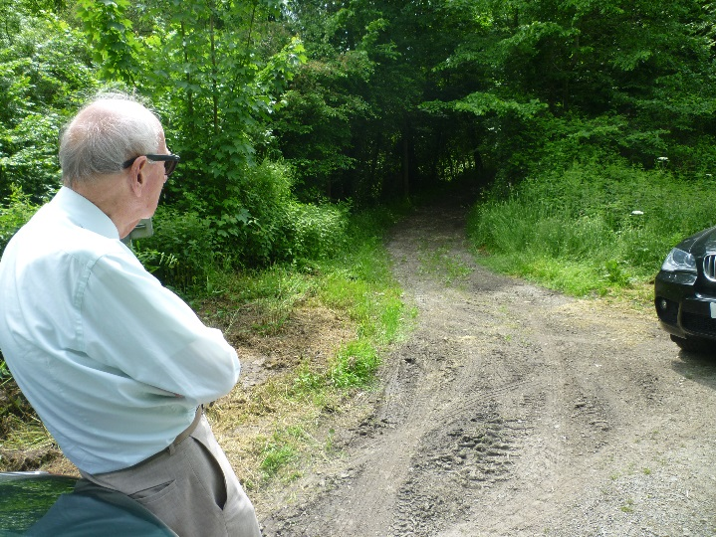
Where B&C Sqns crossed the Noireau near Berjou Capt Render at the track taken by A Sqn in 1944

The ceremonies at Bayeux and Tilly were, as always, well attended by local people and visitors. At Bayeux, our ceremony has become an important commemoration of the liberation of the town on 7th June 1944 and this year, for the first time, we introduced some local participation to the Bayeux ceremony. The Mayor made an opening speech, the lesson was read in French as well as English, and local schoolchildren provided a choir and laid flowers on the memorials during the ceremony.

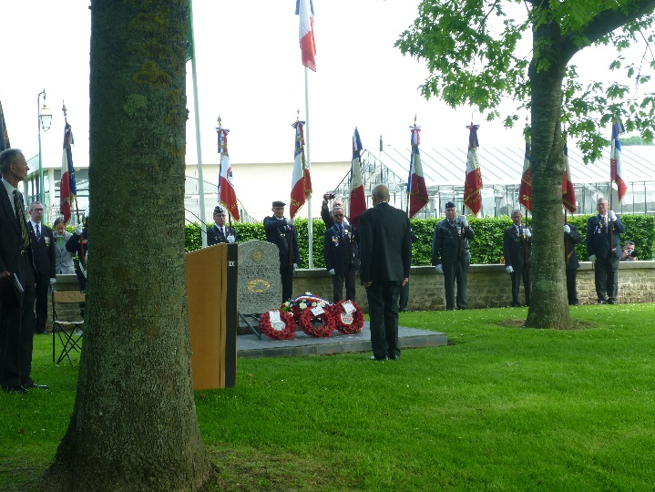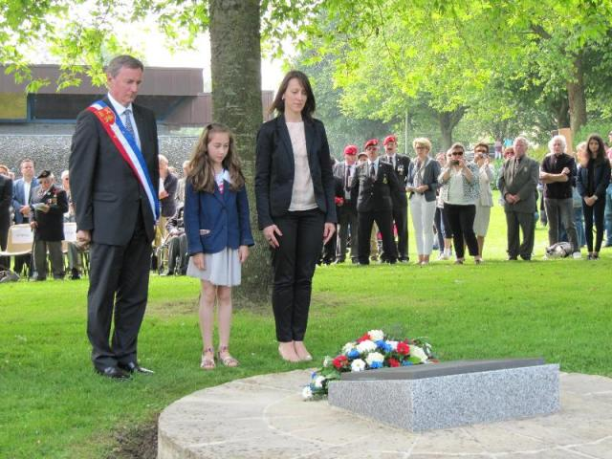
Capt Render laying a wreath at Bayeux The Mayor of Bayeux and helpers

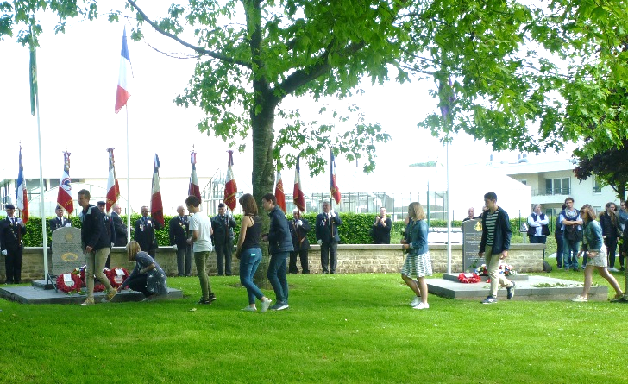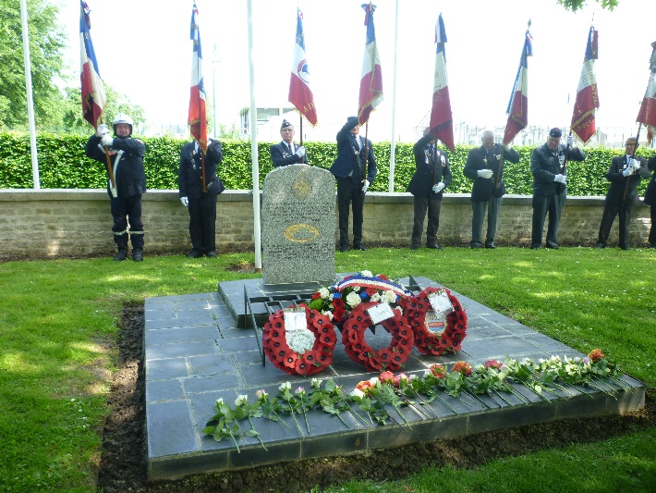
The children laying flowers on the Memorials The SRY memorial at Bayeux

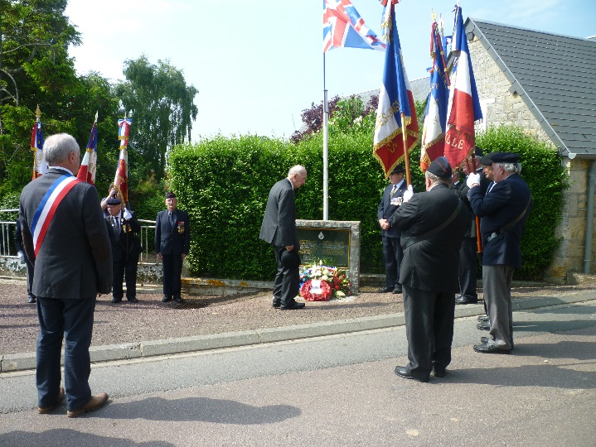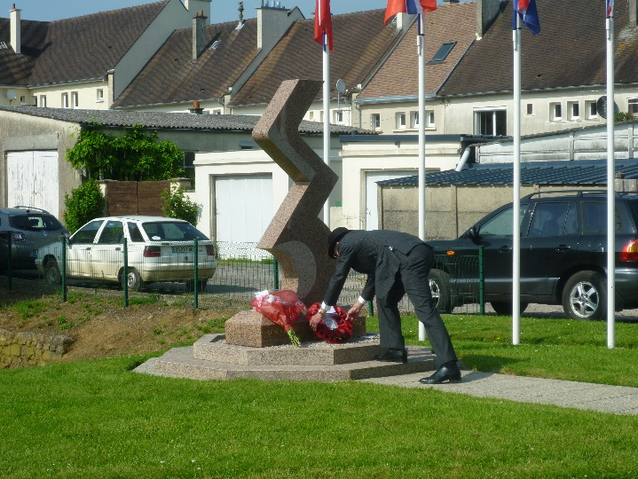
At the SRY memorial at Hélie Farm at St Pierre The Civilian memorial at Tilly-sur-Seulles

NORMANDY JUNE 2017

This year we plan a major event with the unveiling of a memorial on Gold Beach at le Hamel on the morning of 6th June. On 5th June we are organising a battlefield tour and the usual ceremonies will again be held at Bayeux and Tilly on 7th June. The tour is now fully booked with over 50 members and guests expected to attend the various events. However, anyone that will be in Normandy at that time, or can make their own way there, would be most welcome to join us at the ceremonies at Gold Beach and Bayeux and Tilly on 6th and 6th June.

WESTMINSTER ABBEY 10th NOVEMBER 2016

The Regiment was represented at the Annual Field of Remembrance organised by the Royal British Legion at Westminster Abbey. Prince Philip and Prince Harry officiated and Philippa D’Eath, whose father was killed at Weeze, was our representative at the head of the plot. Capt Render represented the Derby Yeo with whom he served after the War. My thanks to all who came and to Capt Nick Robinson for placing the crosses.

This year the ceremony will be held on Thursday 9th November. For security reasons, tickets are required. So, if you would like to attend, please let me know by the beginning of September.

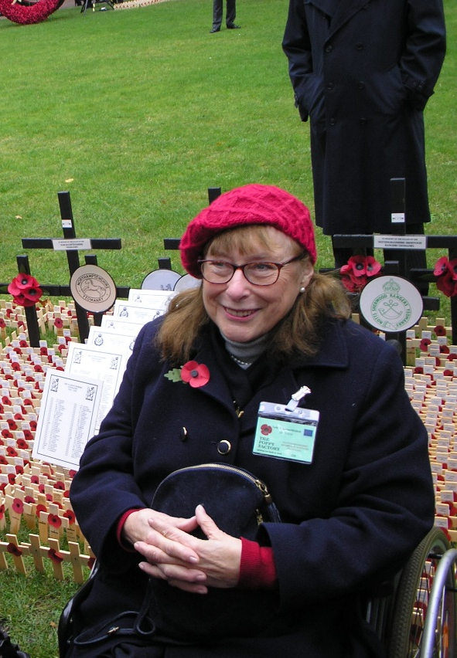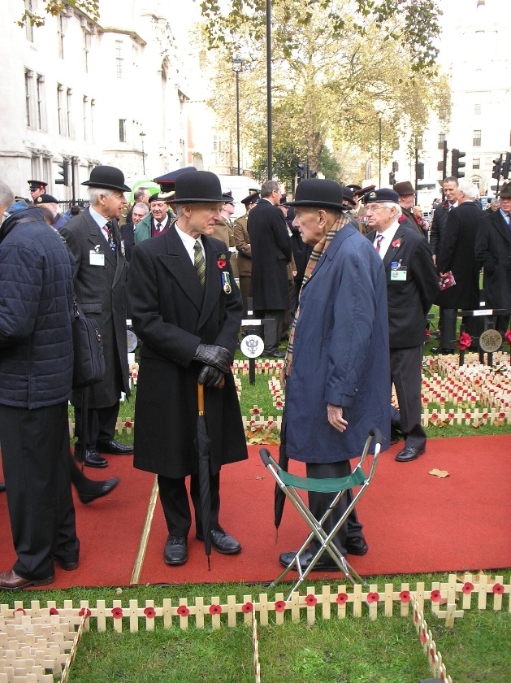
Philippa D’Eath at the head of the SRY Plot Capts Robinson and Render

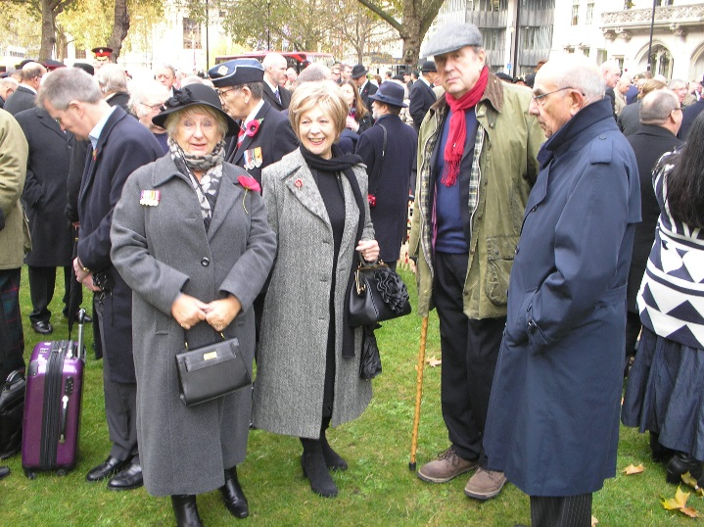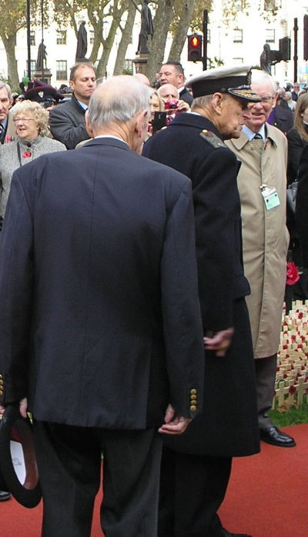
Jan Andrews, Maureen Hutchinson, Kit Pike & Vic Benson Capt Render with Prince Philip

REMEMBRANCE DAY 13th NOVEMBER 2016

As usual, the Sqn paraded in Newark on Remembrance Day. Afterwards, all gathered for a curry lunch at Carlton.

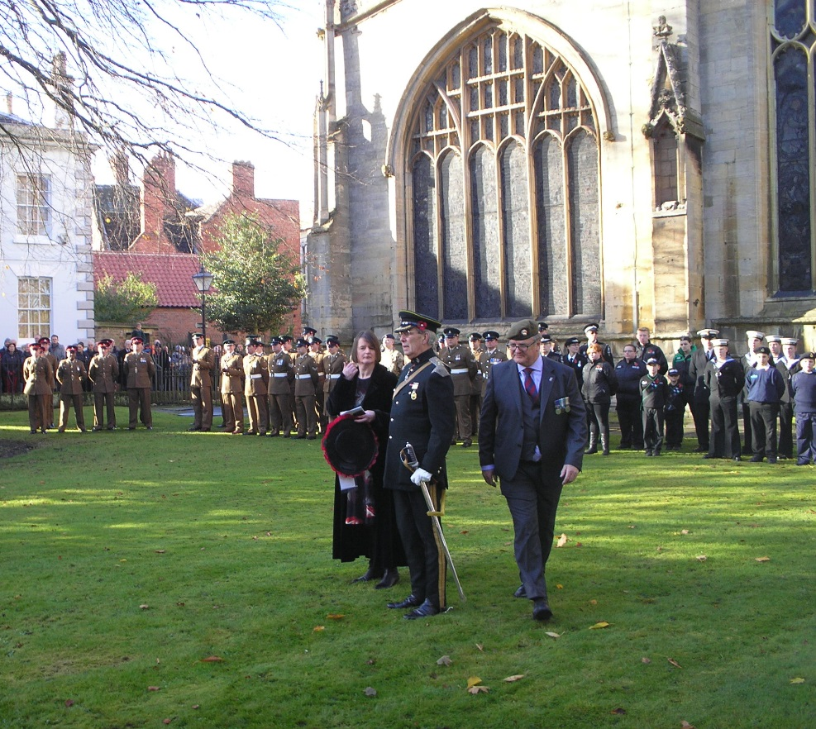
Brig Browne with the Squadron on parade at Newark

The people of Newark always turn out in force to see “their” regiment. In recent years, however, the number of Old Comrades attending has dwindled and I hope that, in future, more retired members will join the parade to support the Sqn.

REGIMENTAL MUSEUM AT THORESBY

The Thoresby museum has had another good year with record attendance and several successful events both for Friends and the public. If you are near and have not seen it, you should definitely go.

See also the website at: www.qrlnymuseum.co.uk

It would be impossible to run such a museum without the assistance of our loyal and hard-working volunteers and we are grateful to all who have stepped forward to assist in this way.

The ability to staff the Museum is the main constraint on opening times and we need more volunteers to allow us to meet out objectives in this regard so, if you would like to volunteer, please let me know. I would also urge those who have not already done so to join as a Friend and support the Museum while taking advantage of the benefits and activities arranged for Friends. To join, please contact:

QRLNY Museum
Thoresby Courtyard
Thoresby Park
Nr Perlethorpe,
Nottinghamshire NG22 9EP

email: curator@qrlnymuseum.co.uk

TANK ACTION

Capt David Render’s book Tank Action has been a great success with more than 6,000 copies sold so far. He has also been invited to speak to serving RAC Troop leaders, for whom the book is to be required reading. It is a gripping story and well worth reading. Copies can be obtained via bookshops or the usual online sources.

ITEMS FOR SALE

I enclose a list of books, ties, buttons and other items for sale together with details of how to order by post. Please send your order to Chris Woodward as shown on the form and not to me. As usual, these items will also be available at the Dinner.

WELFARE

I should like to remind you that I rely entirely on members to keep me informed about other members, particularly those in need, so, if you know of someone who needs help or a visit, please inform me or one of the Branch representatives and we will do what we can to assist them, either practically or financially. I am sure that I speak for all members in saying that we continue to be most grateful for all the work done by Don Brown and others in visiting and supporting our less fortunate comrades.

WIDOWS’ FUND

Thanks to the generosity of members, the Widows’ Fund had another successful year. We raised £1,845 and were able to send out gift vouchers worth £40 to each of 48 widows at Christmas. I received numerous letters of sincere thanks and there is no doubt that this effort is appreciated. What is most important is that the recipients know that they are not forgotten.

As in previous years, I am extremely grateful to Capt David Render, who raised well over half the total through the proceeds of his popular lecture series, and to his friend Vic Benson (ex-RMP and City of London Police) who helps on these occasions. I would also like to thank the members of the Midlands Branch for its donation and all those who made personal donations, large or small.

TAX RELIEF ON DONATIONS

As a registered charity, the Association can claim tax relief on the amount of any donation, however small, provided the donor signs a declaration that tax has been paid on the amount given. This also applies to donations to the Widows’ Fund (see above). Hence, if you are a taxpayer and have not already signed such a declaration, please complete and sign the declaration on the proforma which will allow us to reclaim tax on any donation that you may make now or in the future.

FINALLY

Please also let me know when you move so that I can keep my address list up-to-date. It is difficult to keep track of everybody. Last year the circulars addressed to the following were returned:

Mr Badcott | - | Nottingham |  | Maj JO Kirk | - | Bedale
Mr EW Bramwell | - | Ilkeston |  | Mr P Leversuch | - | London
Maj CW Bridgeford MC | - | Toronto, Canada |  | Capt RLW Marsh | - | Hurley
Mr ES Corthorn | - | Nottingham |  | Mr FC Martin | - | Crawley
Mr GW Croxton | - | Launceston |  | SA Nelson Lucas Esq | - | Milton Keynes
Mr D Falkner | - | Gedling |  | S Round Esq | - | Bridgenorth
Mr R Fletcher | - | Clifton |  | Capt ACG Shields | - | Melton Mowbray
Mr G Froggat | - | Ilkeston |  | Mr D Smith | - | Nottingham
Mr AF Gibbons | - | Mansfield |  | Mr P Torrington | - | Nottingham
Mr Grice | - | Nottingham |  | Mr A Watson | - | Retford
Mr Hansford | - | Nottingham |  | Mr CS Watts | - | Nottingham
Mr Haystead | - | Grantham |  | Mr D West | - | Leicester

If you have any news of them or of anyone who did not receive this circular, please let me know.

My thanks to all who have contributed to this newsletter, particularly to Mrs Secretary, Vic Benson, Mrs Ann Barrow and others who have supplied me with photographs. Also to Capt David Render, John Maltby and the Midlands Branch Committee and all those that helped to organise the Dinner last year, as well as to Maj Angus Jenkins, SSM Graham Mudd and Capt Karl Stone at Carlton for all their help throughout the year.

I look forward to seeing as many of possible of you at the Dinner and at other events during the year.

Yours sincerely,

Mike Elliott

ANNUAL GENERAL MEETING

The Annual General Meeting of the Association will be held at Carlton at 6.00pm on Saturday 22nd April 2017. The Agenda will be as follows:

1. Apologies 5. Officers and Trustees
2. Minutes of last AGM 6. Reports from the Branches
3. Matters Arising 7. Welfare Matters
4. Treasurer's Report and Accounts 8. Any Other Business

MINUTES OF THE ANNUAL GENERAL MEETING OF
THE SHERWOOD RANGERS YEOMANRY REGIMENTAL ASSOCIATION
HELD AT CARLTON ON 16th APRIL 2016

Present: Capt Render (President), Col Hunt (Chairman), Maj Cornish (Treasurer), Capt Elliott (Secretary) and 20 other members

1. Apologies for Absence - Received from 10 members

2. Minutes of last AGM - The minutes of the last meeting were approved.

3. Matters Arising - None

4. Treasurer's Report

Maj Cornish presented the accounts for the year ended 31st Dec 2015 which had been approved by the Trustees in their meeting just finished. These showed a deficit of £915 which included the £500 donation towards the memorial window at Southwell Minster.
The accounts were approved, proposed by Col Hunt and seconded by Mr Freeman.

Col Hunt thanked Maj Cornish for all his work as Treasurer.

5. Officers and Trustees

Capt Elliott reported that Capt Render had agreed to serve as President and his appointment was unanimously applauded. Also that SSM Mudd had succeeded SSM Stone as a Trustee ex-officio.

6. Reports from the Branches

Mr Maltby reported that the Midlands Branch was doing well and gaining members. The accounts had now been reviewed and he was confident that they were in order.

Col Hunt reported that the Arnold Branch was now remarkably strong.

7. Welfare

Mr DHF Brown reported on his work in visiting and supporting our less fortunate members. Col Hunt thanked him for all his efforts on behalf of the Association.

Col Hunt also thanked Capt Render and his assistant Vic Benson for their remarkable contribution in raising funds for the Widows’ Fund.

9. Any Other Business

Maj Cornish said that the memorial window at Southwell Minster would be dedicated in a service to be held on 10th July and he encouraged members to attend.

Capt Elliott thanked all those from the Squadron and the Association who had helped in organising the Dinner.

MAE
24 May 2016

MIDLANDS BRANCH ANNUAL REPORT 2016

I am pleased to report that the Branch has had a very good year. I am also pleased to report that the Branch is in a good financial position due to the concerted efforts by Mike Freeman the Vice Chairman, along with the continued support from the Branch Committee and membership.

New members are always welcome. All ex members of the SRY, serving members or ex members of the RY, or if you were, or are attached to either, or are affiliated to the SRY, are automatically a member of the Midlands Branch by right. We will always be pleased to see you at our monthly meetings, which are held on the fourth Wednesday each month at the TA Centre Carlton, by kind permission of the Squadron Leader Major A D Jenkins.
Please remember to let us know your full address and telephone number so that we can keep you informed of our Branch activities.

Visits and events during 2016
The Branch had a very busy 2016 starting with the Regimental OCA Annual dinner in April, and in May, the OCA Cavalry Memorial Parade in Hyde Park.

The Branch attended the Armed Forces day event at Wollaton Park Nottingham, where we had a stall, and members of the Midland Branch took part in the Drumhead Service

In October our Branch had its now annual trip to Bournemouth. Unfortunately, this was marred by the health problems of some of our members, which slightly reduced the numbers, but, after a subdued start the weekend proved to be a great success.

Our Remembrance parade took place as usual in Newark on Sunday 13th November. I would ask those who are able to make a concerted effort to boost the numbers next year. If you have a problem with transport, please would you make any of the branch committee aware and we will always try to assist whenever possible.

Moving into 2017 on the 14th January the Branch had a late Christmas Dinner at the Vale Social Club, Colwick and, with more people attending, this was another great success.

Our AGM was held on the 22nd February at Carlton ARC, which was followed by our normal Branch meeting.

The Current SRYA Midlands Branch Committee as from 24th February 2016, and until the February 2019 AGM is as set out below. (The Branch voted for a 3 year tenure at the last AGM).

Chairman Mr John Maltby
Vice Chairman/Ass Treasurer Mr Mike Freeman
Secretary Mr Tony Higton
Treasurer Mr Chris Woodward
Welfare Visitor Mr Don Brown
Assistant secretary Mrs Ann Barrow
Newsletter Editor Vacant

Branch attendance, over the eleven 2016 meetings at the Carlton ARC has held up, with an average of 30 per meeting.

On the Welfare side, if you are aware of anyone who has passed away, is suffering, or in need, please contact Donald Brown or any committee member. The Midlands Branch has always had special interest in the welfare of the Association members and widows, and we actively support the Widows’ Fund.

Tony Higton,
Midlands Branch Secretary

Major John Semken CB MC
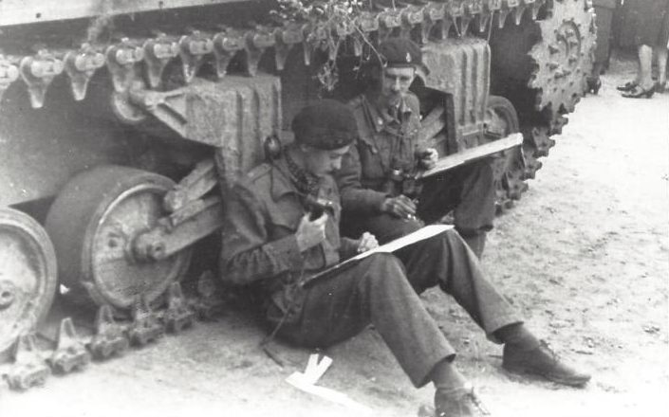
Semken, on left, in the Netherlands in late 1944
Major John Semken, who died aged 95 in March last year, was awarded an MC and the American Silver Star in 1944; he subsequently had a successful career at the Bar and with the Home Office.
On June 11 1944, shortly after landing in Normandy, the Sherwood Rangers Yeomanry’s Regimental HQ was in a farmyard at St Pierre, near Tilly, when it took a direct hit from an artillery shell. The CO was killed and Semken assumed command of A Squadron from his role as technical adjutant – in which he had re-equipped SRY from scratch as an amphibious armoured regiment for D-Day.
On June 26, the second day of the battle for Fontenay-le-Pesnel, the regiment was ordered to attack south. Semken was leading his squadron through the village to his start line when he came face to face with a Tiger tank. He immediately ordered his gunner to fire. He fired four shots before the Tiger was able to retaliate, knocking out the tank.
A and B Squadrons’ advance was then held up by enemy tanks which attacked in strength to their front and from their left flank. The Germans were dazzled by the setting sun and the reflections off their hulls made them easier to spot. Semken exploited this and deployed his squadron with such skill that he knocked out eight tanks and reached the village of Rauray without a single loss to his own force. He was awarded an Immediate MC.
John Douglas Semken was born in London on January 9 1921 and educated at St Alban’s School. In 1938, he was articled to Sir Louis Gluckstein of Bartletts & Gluckstein, a London firm of solicitors, of which his father was a partner, and he joined the Inns of Court Regiment at the same time.
He was commissioned in March 1940 and joined the SRY in Palestine in October that year just prior to it being converted to an armoured regiment. He took part in the whole of the North African campaign as a troop leader, starting with the battles of Alam el Halfa and El Alamein.
In November 1944 the SRY was supporting the 84th US Infantry Division in an action to breach the Siegfried Line at Geilenkirchen. Semken led A Squadron in an action to force a crossing of a railway line which was guarded by a minefield. When the flail tank ahead of him was immobilised by a mine, he took over the lead and his luck held until he was almost through the field. His tank was then blown up by multiple explosions.
His squadron was through but they had to continue without him. That evening, the padre went in search of him and found him in a captured block-house reading poetry. He was awarded the Silver Star.
Semken was demobilised in 1946 and went up to Pembroke College, Oxford, where he read Jurisprudence. He was one of a group of undergraduates who subscribed for and commissioned a Junior Common Room war memorial, a fine sculpture, which stands by the door of the chapel.
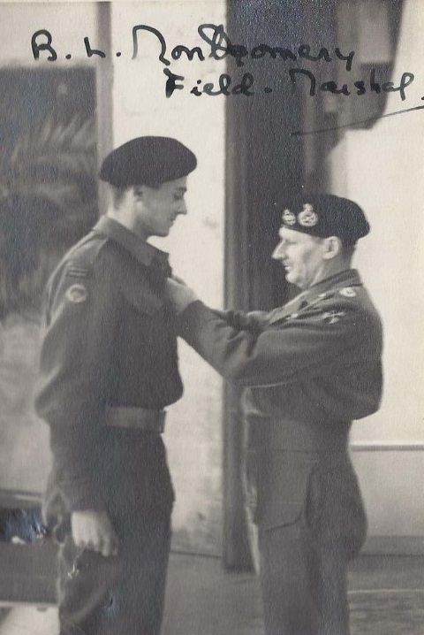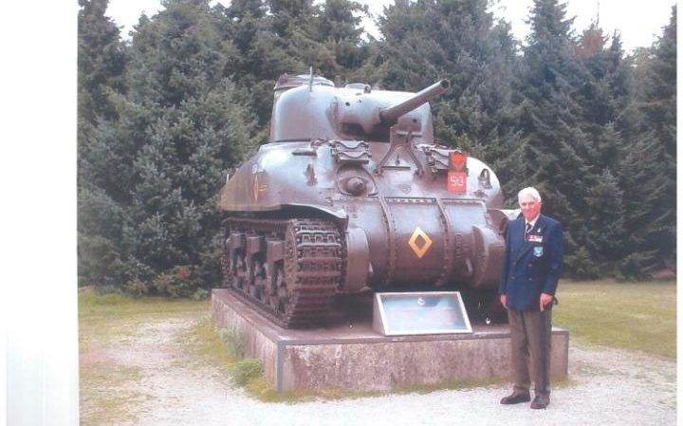
Semken being decorated by Montgomery In later life at the SRY memorial at Groesbeek
He was called to the Bar by Lincoln’s Inn in 1949 and practised at the Chancery Bar until 1954 when he joined the Legal Adviser’s branch of the Home Office. He became head of that department in 1977, and a member of the Criminal Law Revision Committee in 1980, retiring in 1983. He endeared himself to the junior lawyers at the Home Office by visiting them in their own rooms to discuss their work and would pepper his advice with aphorisms like “that cock won’t fight” or “that’s a horse of an entirely different colour”.
He retired to Aldeburgh. He was appointed CB in 1980 and was awarded the Légion d’Honneur in 2015. He was a strong supporter of the Association, particularly the Southern Branch. For many years he led our battlefield tours and those that took part will always remember his erudite narratives of the troubled history of Flanders as we drove across “the cockpit of Europe”.
John Semken married, in 1952, Margaret Poole. She predeceased him and he is survived by their three sons.

the sherwood rangers yeomanry regimental association
annual reunion dinner - Saturday 22nd APRIL 2017
The Dinner will be held at the TA Centre, Cavendish Drive, Carlton, Nottingham at 6.30 for 7.00 pm on Saturday 22nd April 2017. Admission will be restricted to holders of tickets which must be obtained in advance using the form below, not later than 12th April. PLEASE APPLY TO ME (or to the SSM if you are a serving member) IN GOOD TIME AND USE THE CORRECT FORM. We will always try to accommodate latecomers but if a large number of people turn up at the last minute it makes life very difficult for the organisers.

Tickets cost £25 each to include wine and port.

-------------------------------------------------------------------------------------------------------------

To: Capt MA Elliott, 20 Millington Road, Cambridge CB3 9HP

Please send me _____ ticket(s) for the annual dinner at £25 each. If ordering more than one
ticket please give the name(s) of your guest(s) below

I enclose £ ________ for the above and £ _________ as a donation to the Association (please make cheques and PO's payable to: "Sry association”)

Name and Initials (BLOCK CAPITALS please) ____________________________________
Address ___________________________________________________________________
______________________________________________ Postcode ________________
Phone ________________________ email______________________________________

Name(s) of Guest(s) _____________________ __________________________
(must be connected with
the SRY or other regiments) _____________________ __________________________

GIFT AID DECLARATION. If you are a taxpayer, have made a donation and have not already completed a declaration, please complete, sign and date the declaration below in order to allow the Association to claim Income Tax relief on your gift:

Full Name ________________________________________ (address as above)

Please treat all my donations until further notice as Gift Aid. I will have paid an amount of income tax and/or capital gains tax at least equal to the tax that the Association reclaims from my donations in the relevant tax year. I will notify the Association if, in the future, I cease to be a taxpayer.

Signed ____________________ Date __________ (This form is invalid if it is not dated)

(Charity for the Benefit of the Sherwood Rangers Yeomanry No. 1069782)

